Programming Focus Track

Research games with that feature

Selection, brainstorm, associations

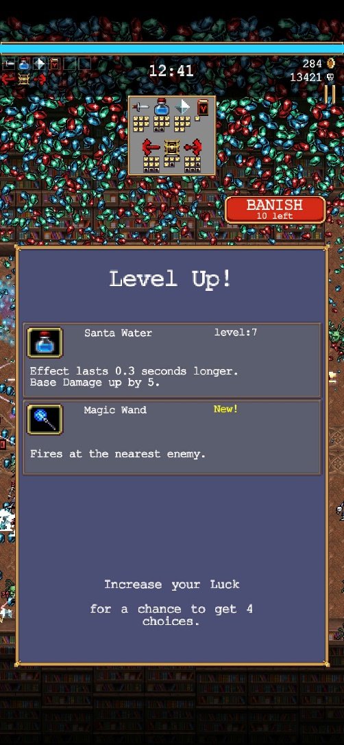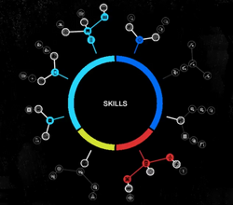

Vampire survivors, watch dogs

Experience Manager: exp pickup inherit pickup

Event calculate steps ->

addlistener

Xp game event inherit game event

Experience Manager addlistener for these things:

* Count distance travelled from starting point
* When a certain number is reached
  + + 10% each time a level up is triggered (number is not removed)
  + required number increased
  + ability point awarded
  + Optionally an “exp to level up” counter is shown
* Show particles when ability point is awarded

Ability point manager addlistener for these things:

* Everything is greyed out initially, darker grey for 2nd layer abilities
* When an ability point is added, the first layer of connected dots lights up in white
* When an ability is clicked that was white it becomes colored, 1 ability point removed, and if no ability points remain everything is greyed out again
* When an ability is clicked that has another non-white connected ability connected to it, it gets added to the first layer and will become white as well when ability point is added
* Each ability that is colored is active and increases stats like walk speed

Canvas Manager:

* Show button that opens ability point manager
* Pop up that shows when you get an ability point
* Ability point manager that is hidden initially
* XP bar

Event Manager (built-in): broadcast to other 3 ^

How can I get 10-15 classes from this?